(Approx. 397 words)

Own the Cloud with ownCloud!
By Drew Kwashnak, Member, Danbury Area Computer Society, CT
January 2012 issue, DACS.doc
www.dacs.org
dacseditor (at) dacs.org

I love the cloud. I love the accessibility, and freedom it provides. Unfortunately that freedom is limited because the host can go offline; hold my files for ransom, or worse! Then there is question about privacy and lack of control over your own content. Proprietary formats create a vendor-lock-in that traps you unwittingly to their services.

Maybe one solution could be a "private cloud" where it gives you the advantages of the cloud, yet you have full control over the content. That's the premise behind ownCloud1.

It is a free, open source project that runs on a Linux web server whether the server is local behind a firewall or hosted somewhere accessible such as on Amazon’s Web Services which, by the way, is where Dropbox stores those files you upload.

The requirements on top of Linux for ownCloud are fairly basic; Apache, PHP 5 and either MySQL or SQLite for database. Some Linux distributions even include a pre-built package that installs everything you need for you.

There are steps to install and run ownCloud on a Windows system, using IIS here outlined in the ownCloud mailing list2. Apple Mac OS X, being UNIX, is almost as easy to host ownCloud in Apache as Linux.

While ownCloud has sharing, music streaming, calendar, contacts, users & groups, OpenID, LDAP, WebFinger, and remoteStorage compatibility the most important feature is WebDAV file storage where you can add, remove and move files through the web browser or from your local computer!

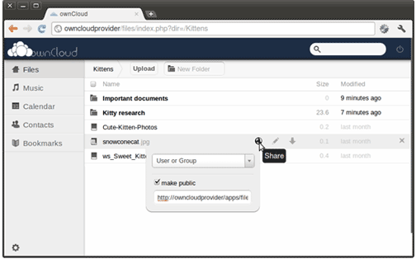
With WebDAV client computers can access the ownCloud files almost as easily as they can open and save files to their local systems! This works in Linux, MacOS X and Windows.

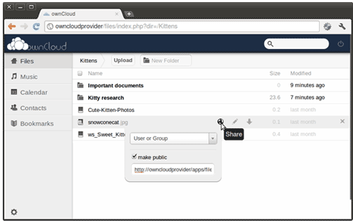
And that’s not all! The developers of ownCloud are working to include an image gallery for your photos, an online text editor, encryption for your security, storage of bookmarks, server and client synchronization and Android or WebOS apps. Being open source, the possibilities are actually practically endless!

So if you like the idea of the cloud, but not the idea of giving control over your files and information to some 3rd party, and if you have some spare machines lying around the house you can easily create your own cloud, where you Own the Cloud!

http://owncloud.org/
http://mail.kde.org/pipermail/owncloud/2011-December/001798.html
http://owncloudtest.blogspot.com/2011/06/what-you-can-do-with-owncoud-today.html



